**DIADOZ  
Version 1.0**

**Local Machine Github Set Up and Installation Guide**

**6 July 2016**

Contents

Overview 1

Github Account Creation 2

Dowloading Git 2

Cloning DIADOZ Repository To Local Machine 2

Add Project To Text Editor 3

Appendix 3

Pulling Code 3

Pushing Code 4

# Overview

This guide will take you step by step, in order to be able to start developing within the DIADOZ environment. The following will be important steps on both setting up Github, as well as making sure you are updated on the most frequent code available every day. With this guide you will be able to:

* Set up Github account
* Download Git and learn the basics
* Clone the DIADOZ repository
* Pull the most updated code everyday
* Push your changes

This guide assumes that you have already chosen a preferred text editor. We recommend using Sublime Text 3 or Webstorm. This guide goes off of Sublime Text 3 and it is on a Windows 7 machine.

# Github Account Creation

* Go to <https://github.com/>
  + Enter in a username, your work email, and password.
  + Go through the setup picking the default choices.
* At this point you will have to head to your email and verify your account.
* Send Mauro or Renzo an email stating that you have created your account and need access to the DIADOZ git team. *Not necessary in order to continue.*
  + Mauro – [state2good@gmail.com](mailto:state2good@gmail.com)
  + Renzo - <ENTER renzo’s email here>
* At this point you can customize your git account, not necessary because we will be mostly working with commands while on this and future projects.

# Dowloading Git

* Go to either and download your respective version.
  + Windows: <https://git-scm.com/download/win>
  + OSX: <https://git-scm.com/download/mac>
* Install with all the defaults.

# Cloning DIADOZ Repository To Local Machine

* Go to <https://github.com/DIADOZ/diadoz-1.0>
* Find the “Clone or download” drop down and copy the git URL.

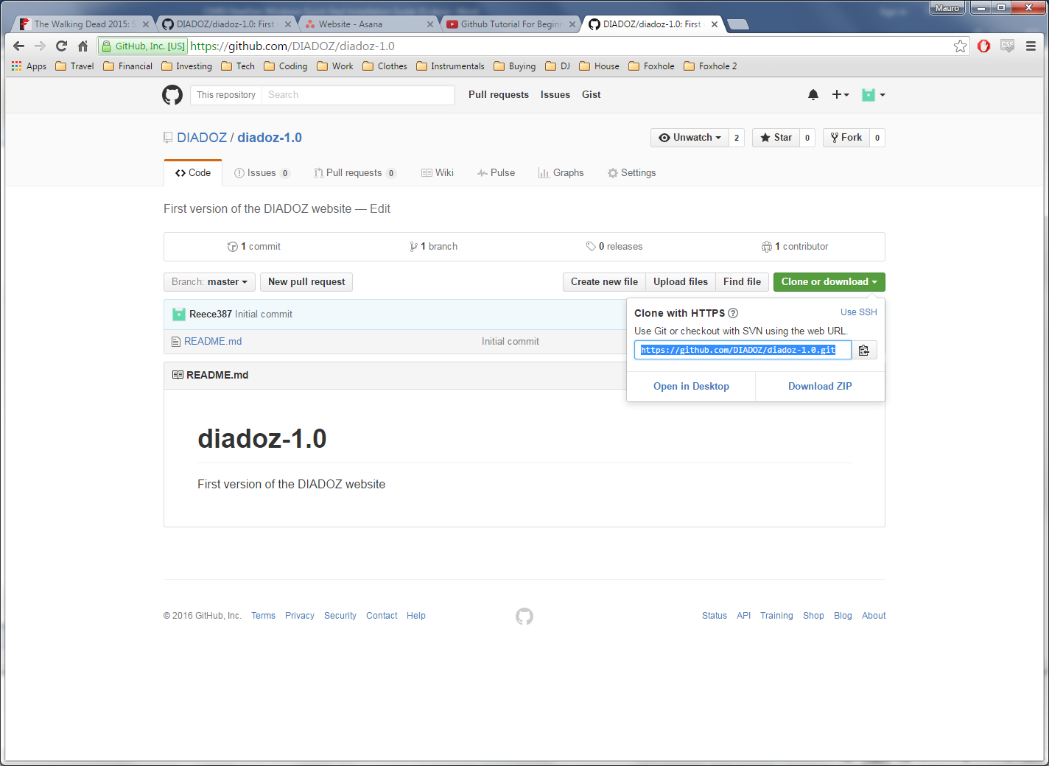

* Open up your command prompt.
* “cd” to the folder where you would like to store the project.
* Type the following
  + git clone <Project URL>

# Add Project To Text Editor

* Open up Sublime Text 3
* Go to Project > Add Folder to Project…

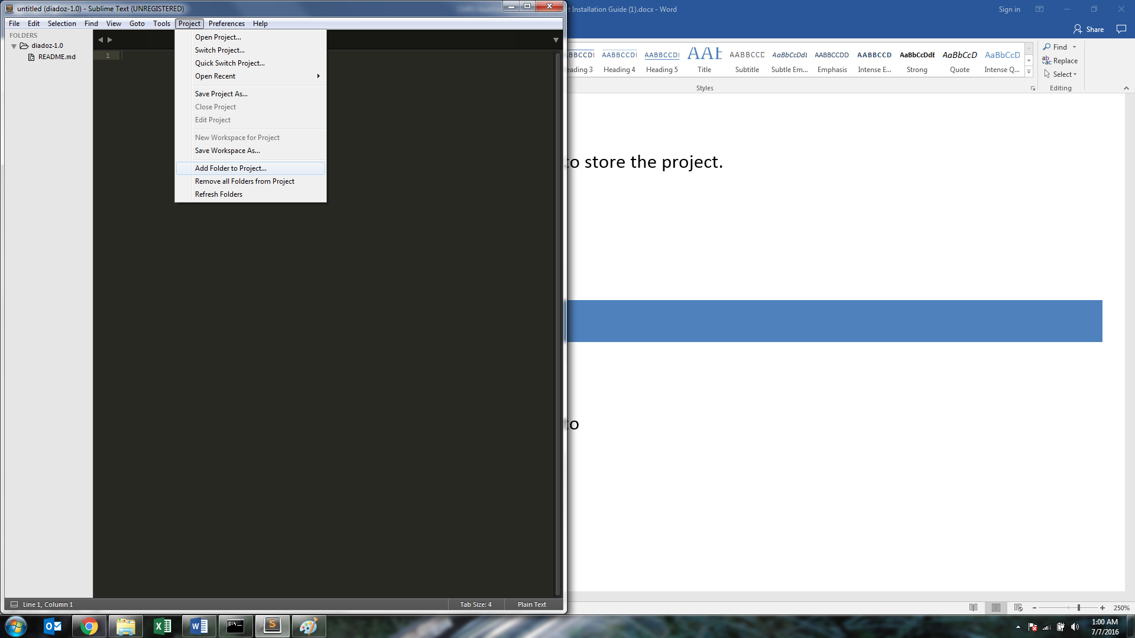

* Add the folder you cloned the project into

# Appendix

## Pulling Code

* Every day at the start your first action should be to pull any code down in case of any changes
* To pull code type
  + cd <Path To Project Folder>
  + git pull

## Pushing Code

* To push up any changes type the following
  + git add
    - <File Name>
    - -a (Which would send all files)
    - . (Which would send all of directory)
  + git commit -m “<Your message explaining your changes>”
  + git push

## Check Git Status

* To check if you have the latest files type
  + git status